Set up a VPC with an Internet gateway, create a public subnet with 256 IP addresses, and a private subnet with 256 IP addresses, make a route table connecting the Internet gateway and the subnets, and launch a Linux EC2 instance by using the above VPC and public subnet.

**First, we need to Set up a VPC with an Internet gateway:**

We need to click on create vpc and we are going to create that.

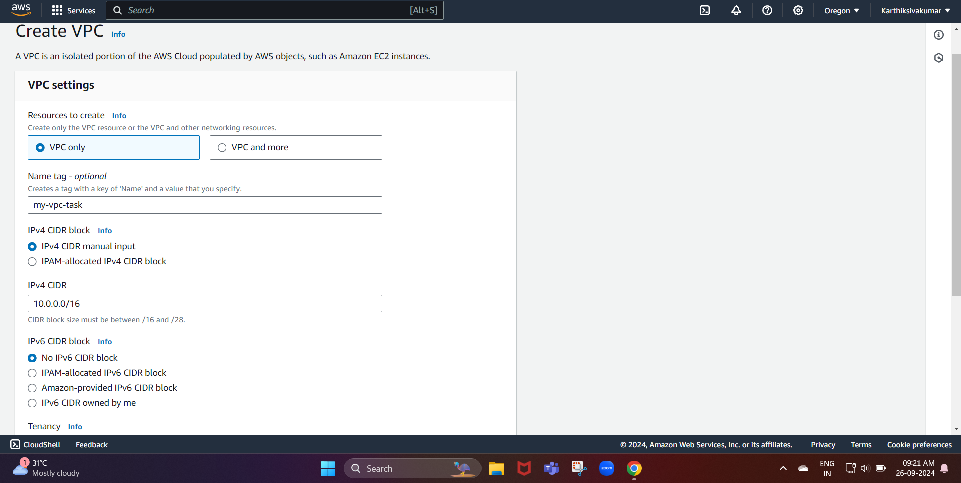

After that, we need to click on Create vpc so that we can create our subnets and other networking components.

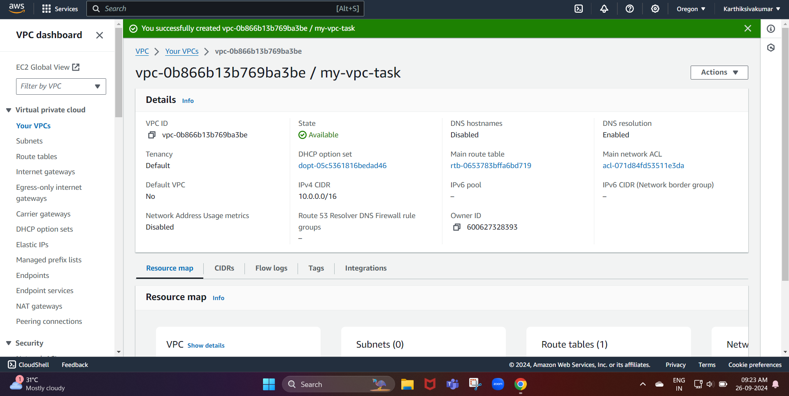

Now, we create our vpc

Next, we need to create the gateway and attach it to the VPC we created.

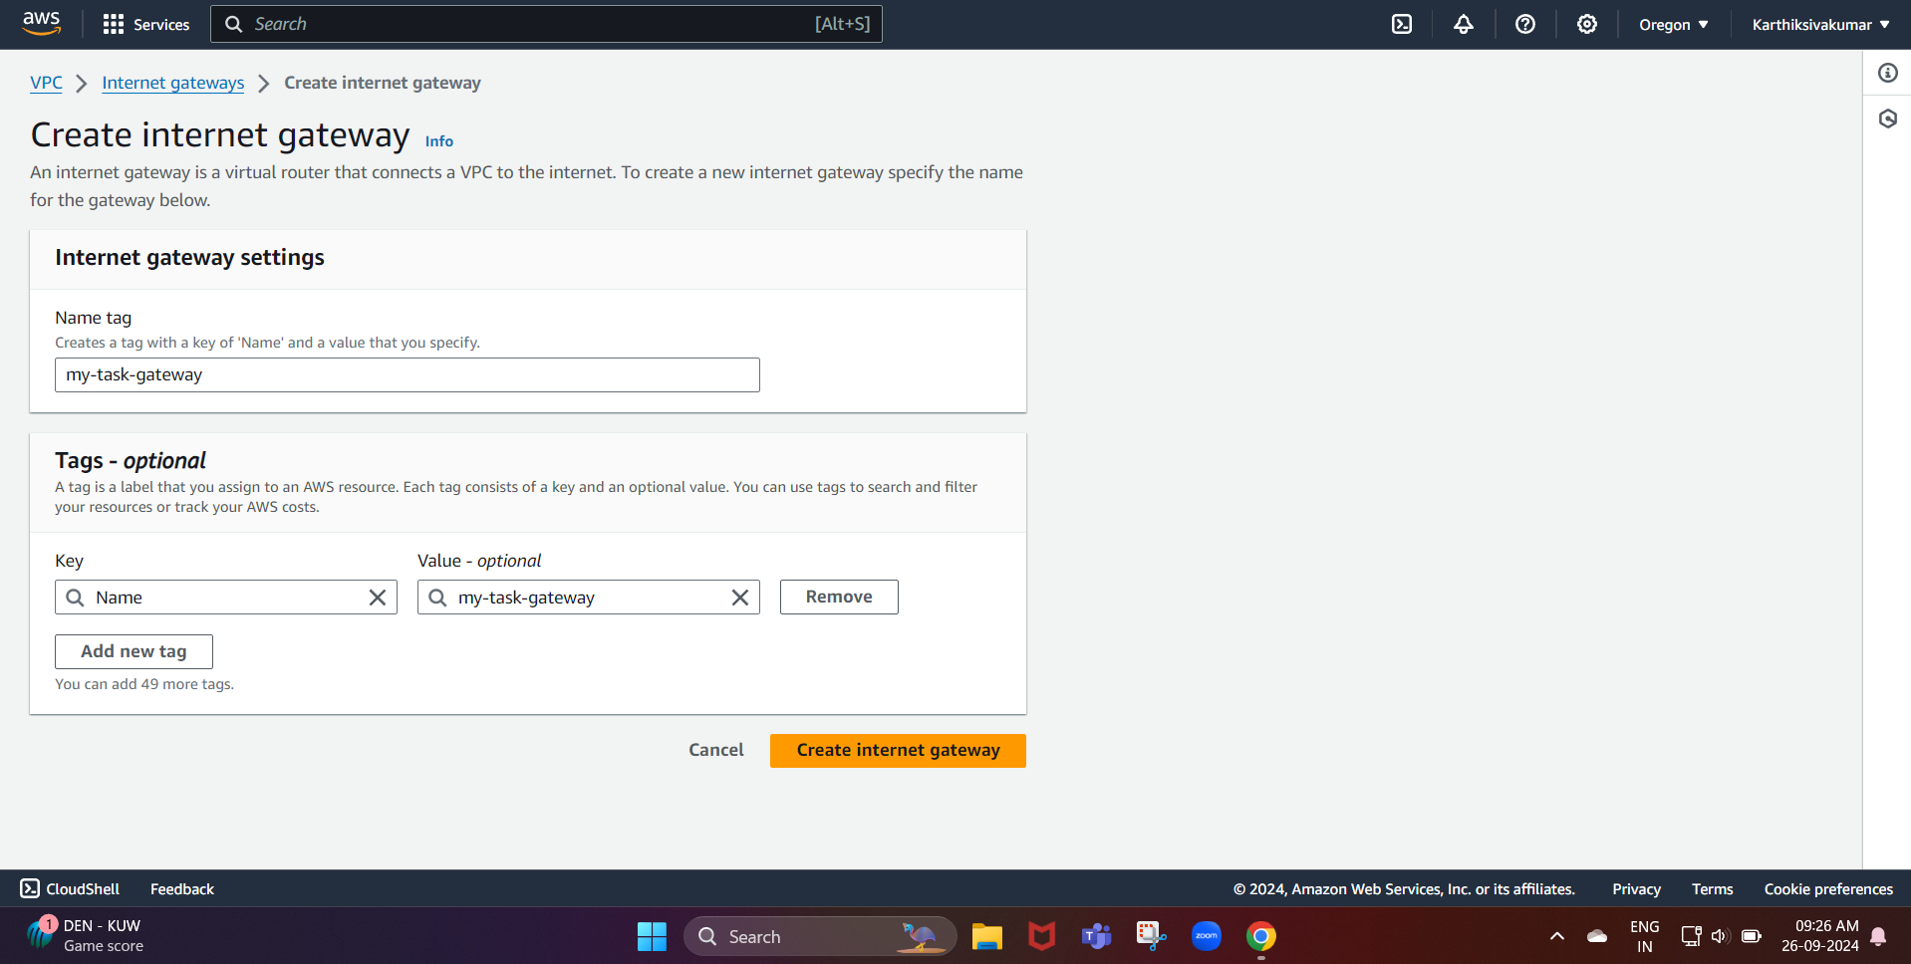

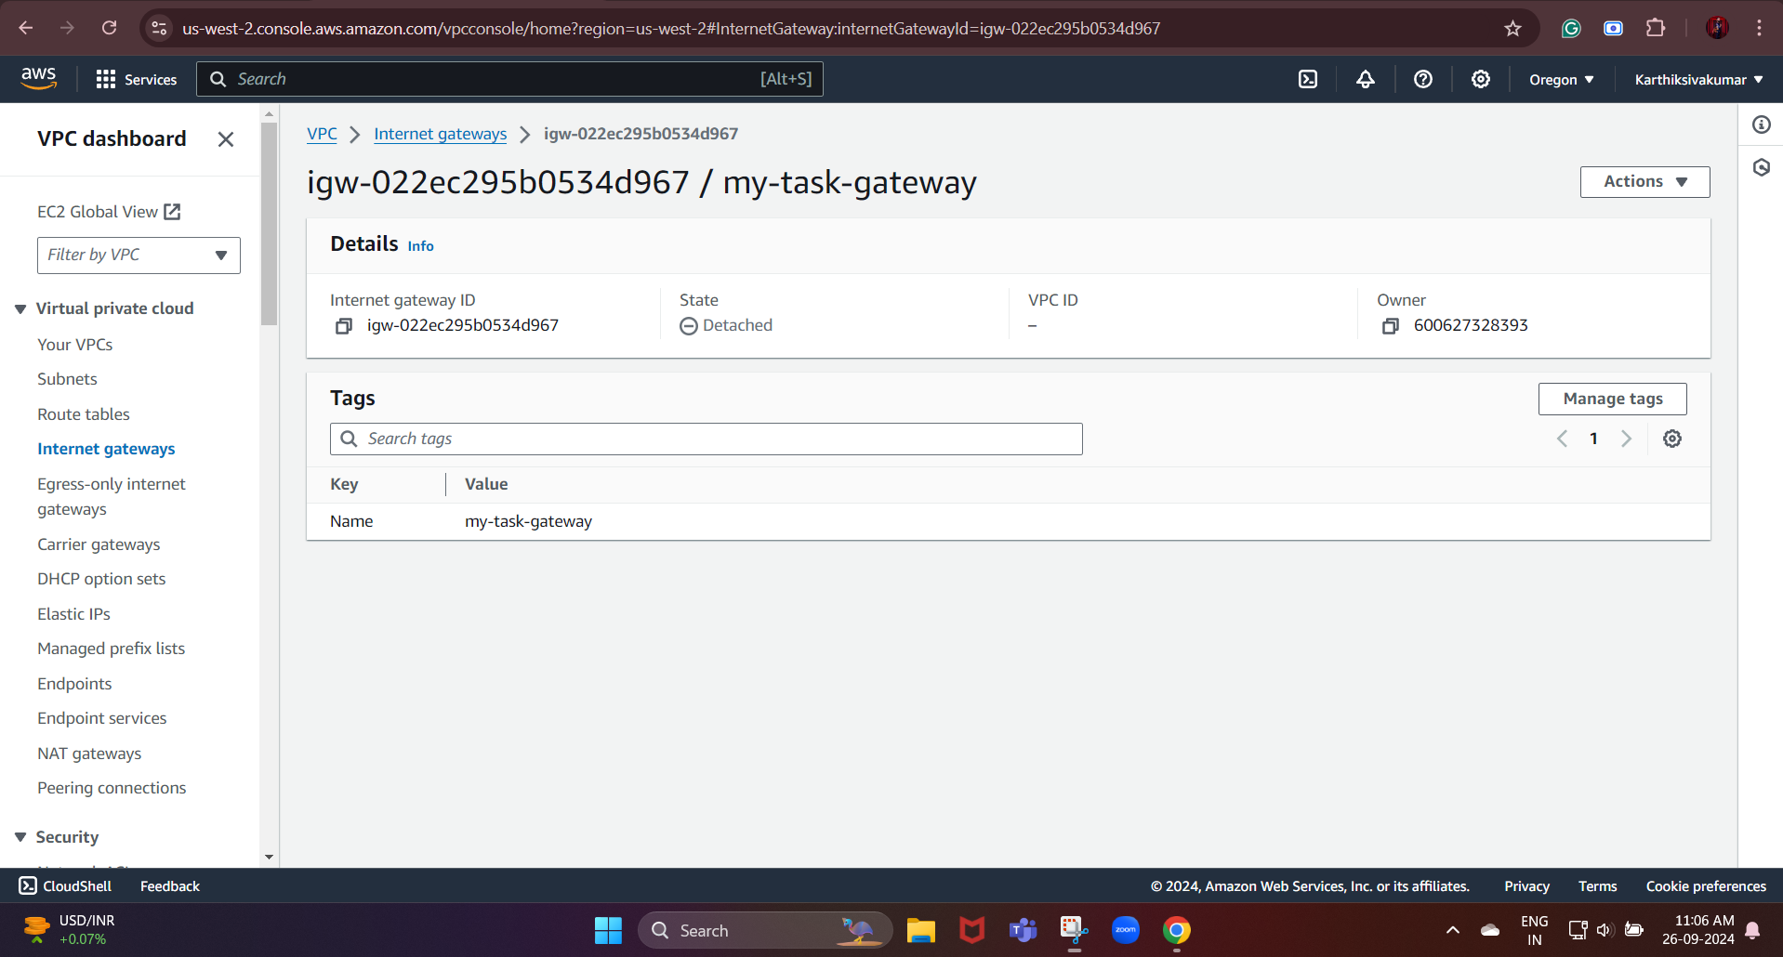

Now, we created the gateway

Next, we need to attach the internet gateway to the VPC we created

An Internet Gateway (IGW) is an AWS component that provides a path for network traffic to travel between a Virtual Private Cloud (VPC) and the public internet.

For that, select that from the action then we need to click the attach VPC

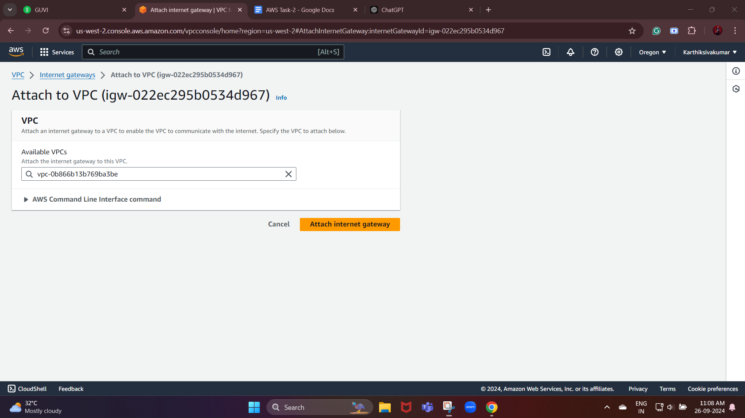

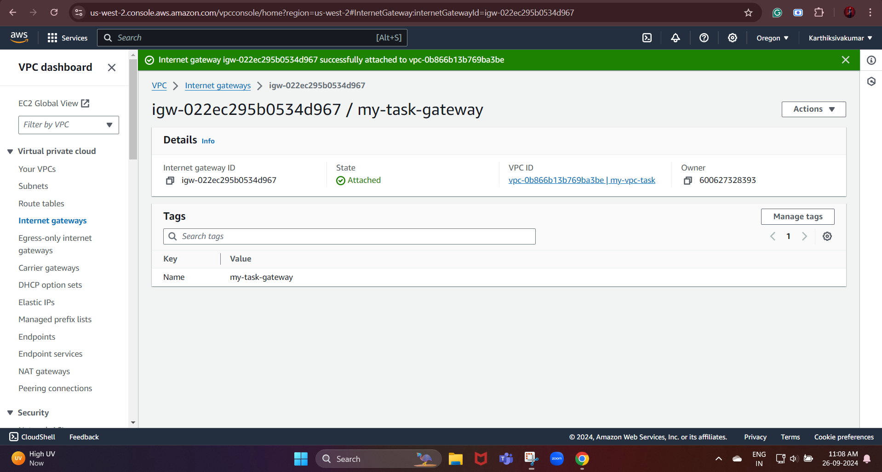

Now, we successfully attached the gateway to our VPC.

Next, we are going to create the subnets:

A subnet is a range of IP addresses within a virtual private cloud (VPC) in Amazon Web Services (AWS).

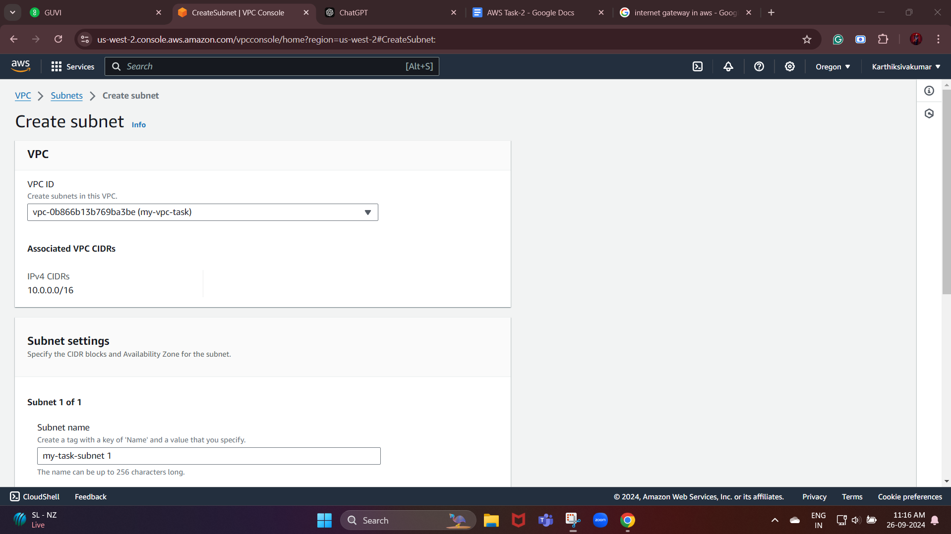

Here we need to attach the VPC we created, and then we need to select the available zone.

IPv4 subnet CIDR block: 10.0.1.0/24 sub 1

10.0.2.0/24 sub 2

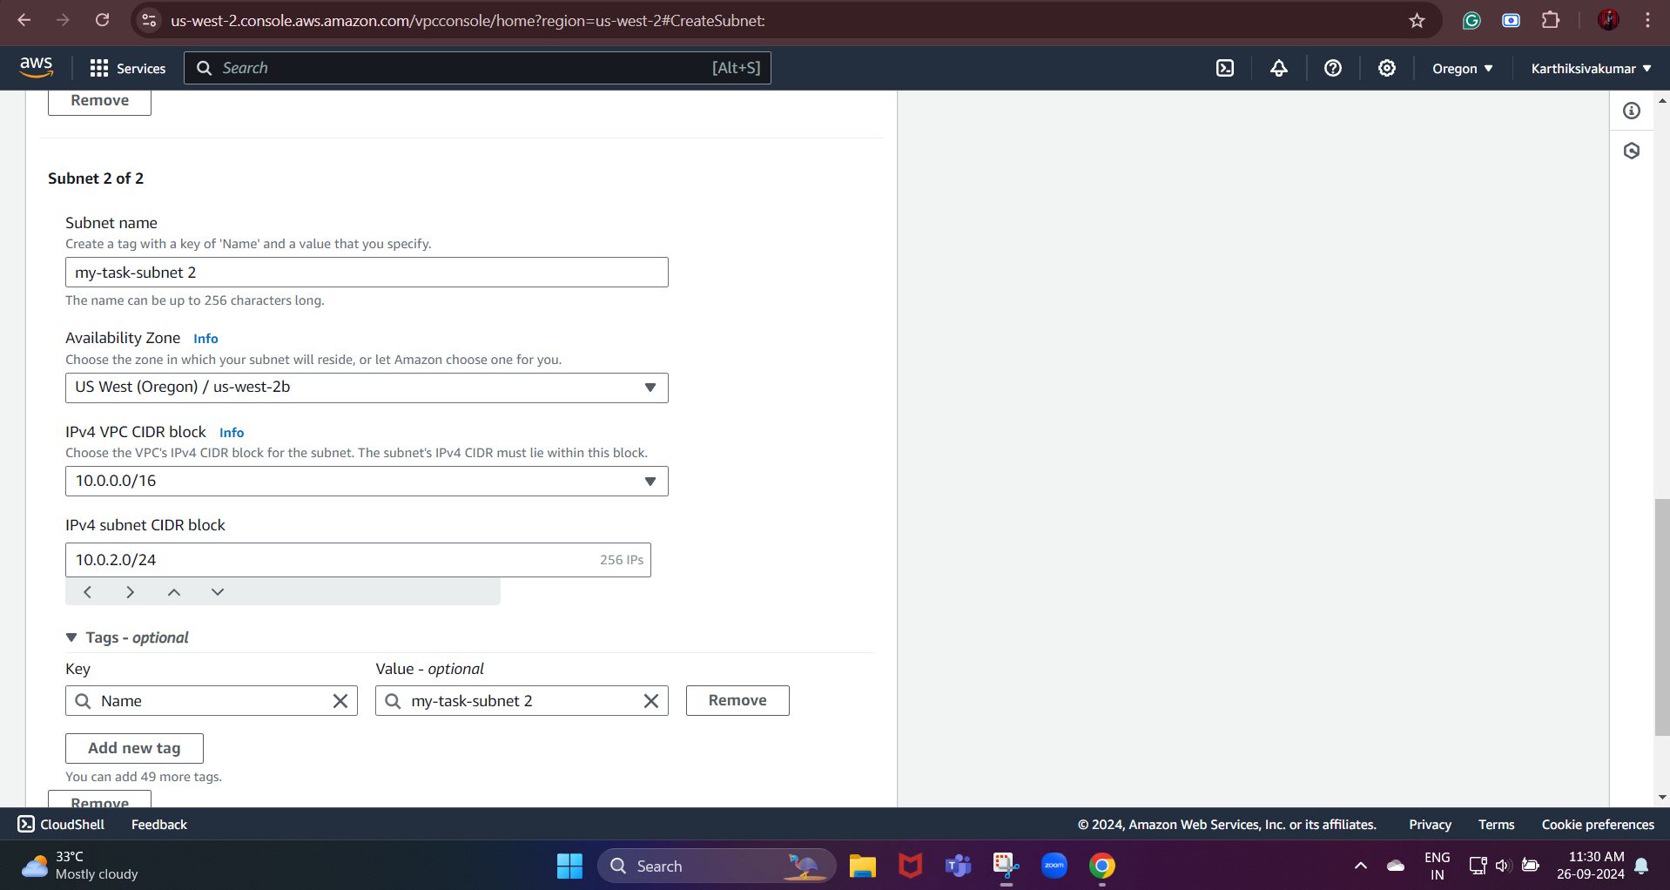

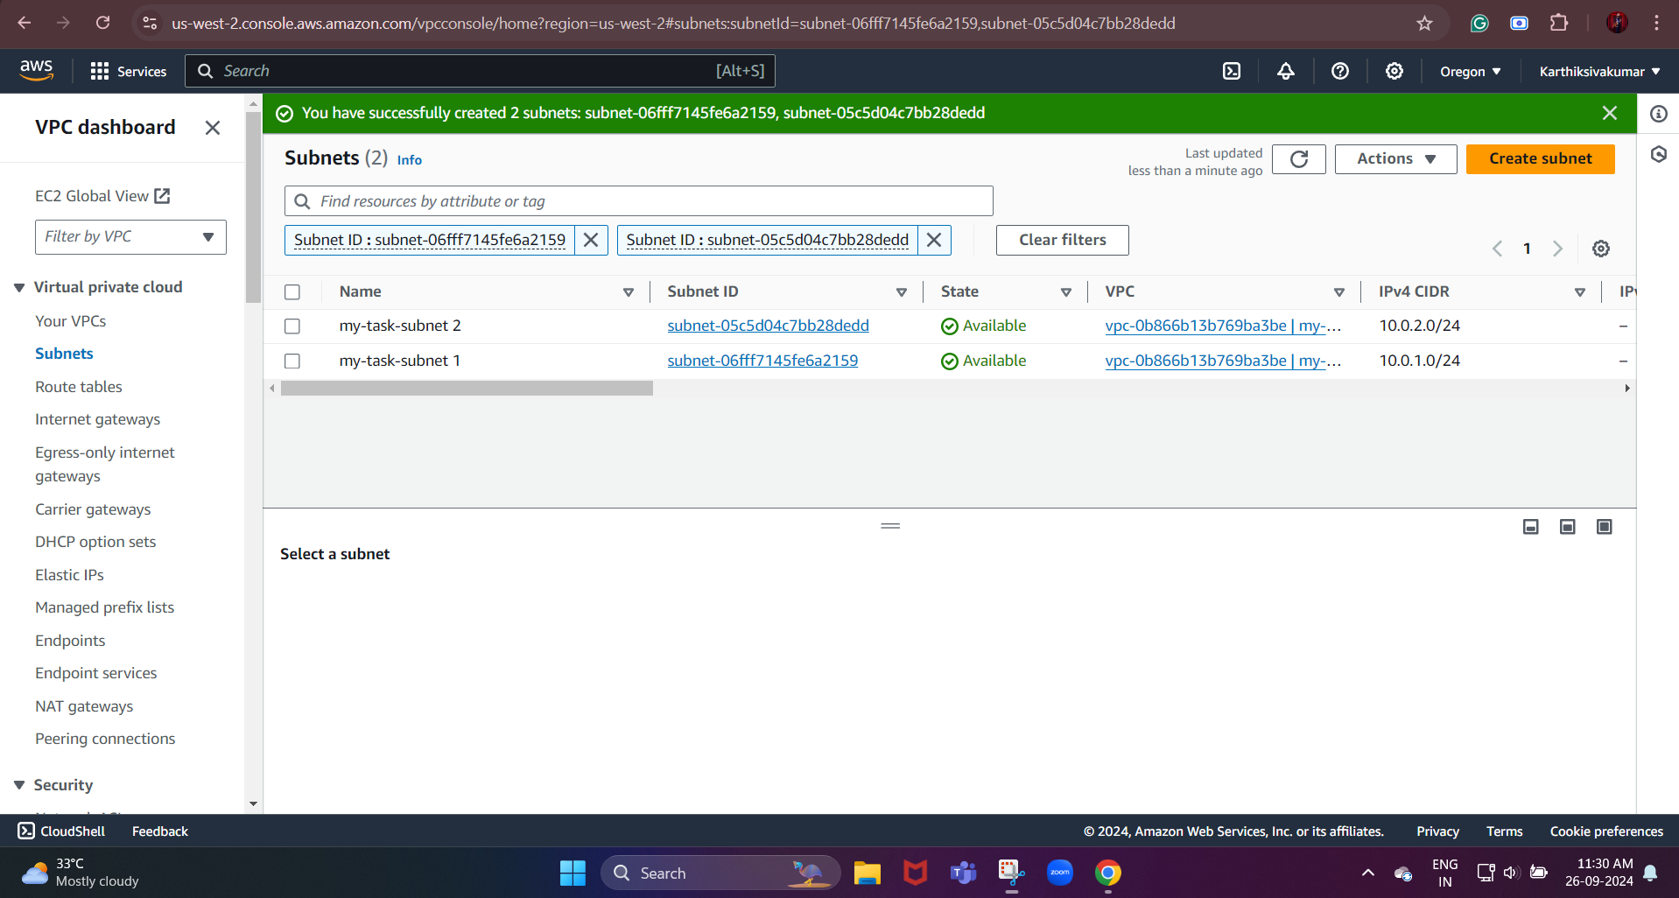

Now, we created our subnets successfully.

Next, we need to create a Route Table

A route table is a set of rules, known as routes, that determines where network traffic is directed.

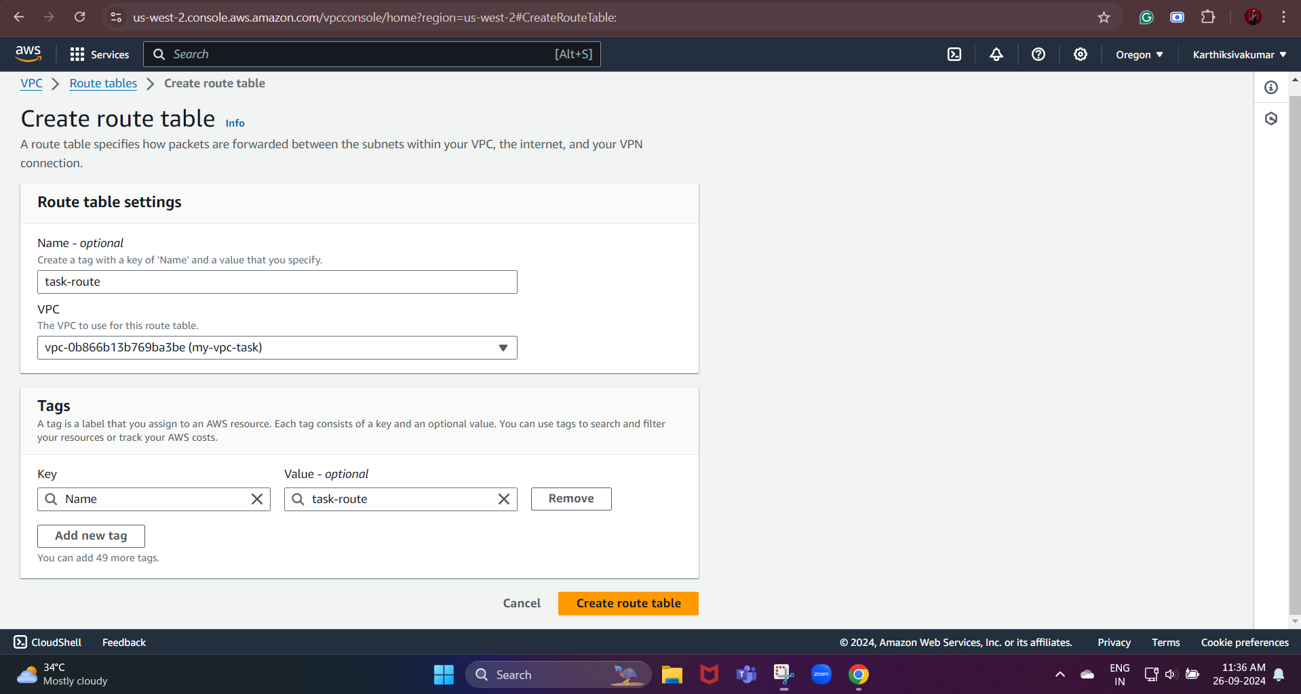

Here, we need to give the name, and we need to select the vpc we created.

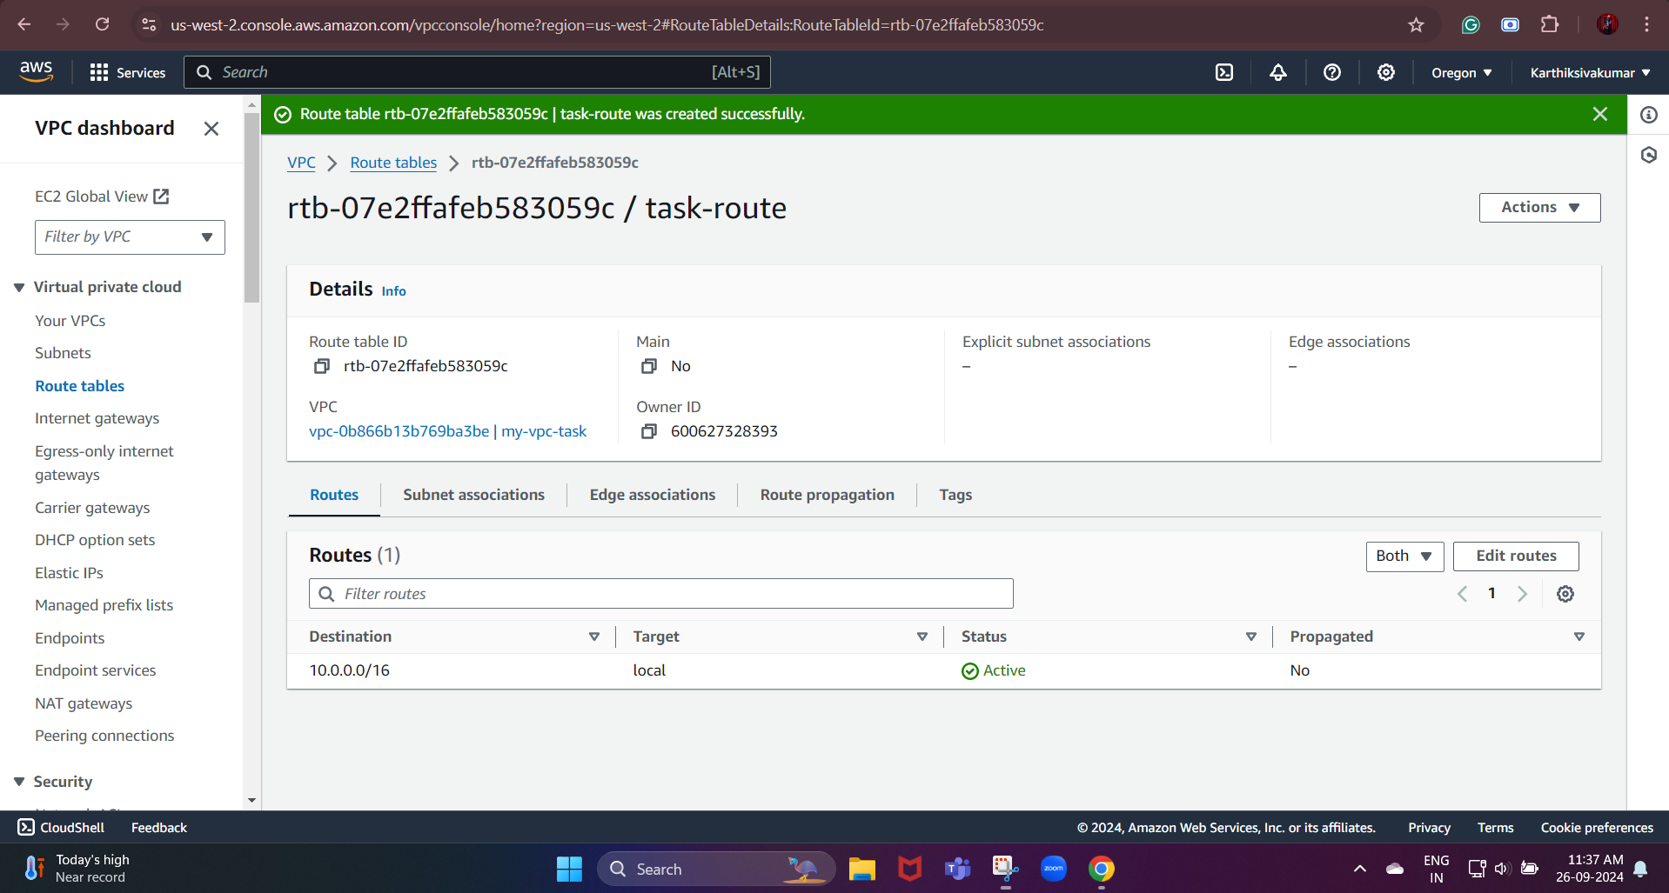

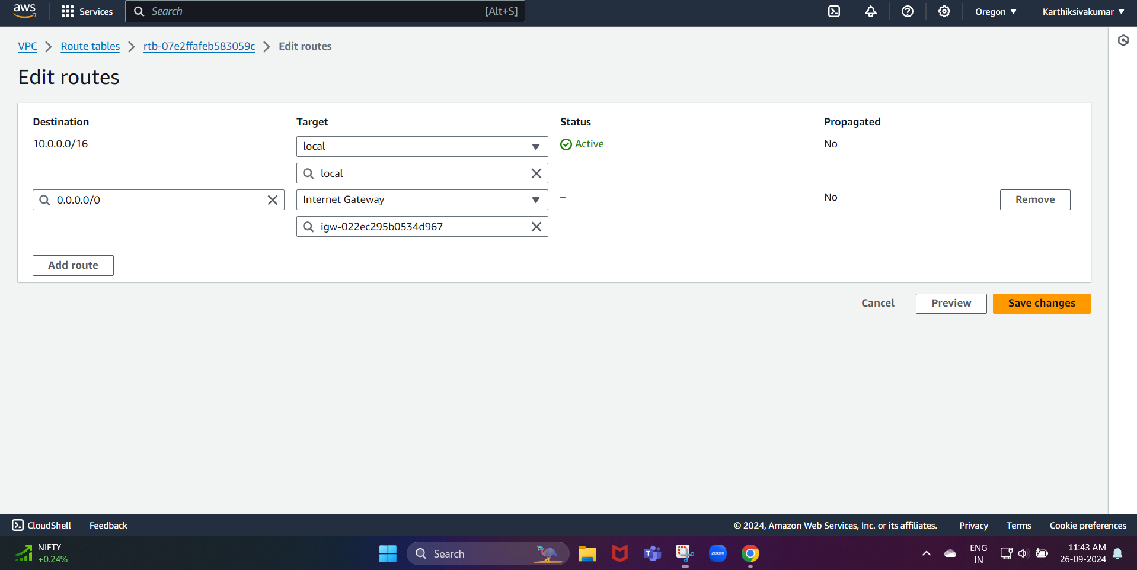

For this, we need to select the route table we created, and then we need to select our internet gateway

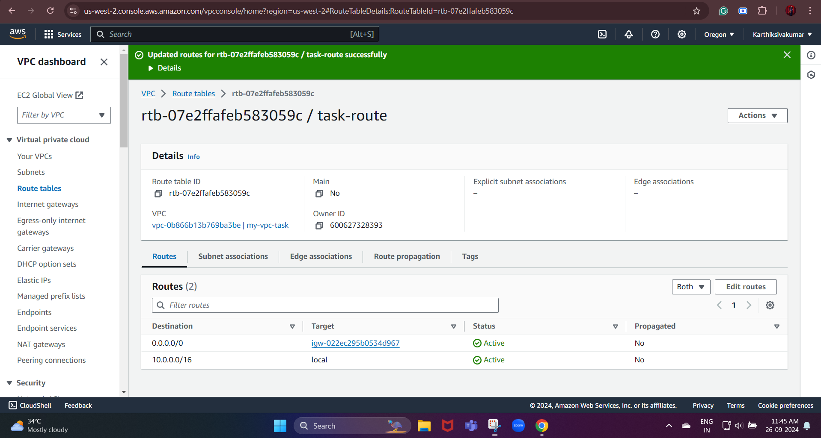

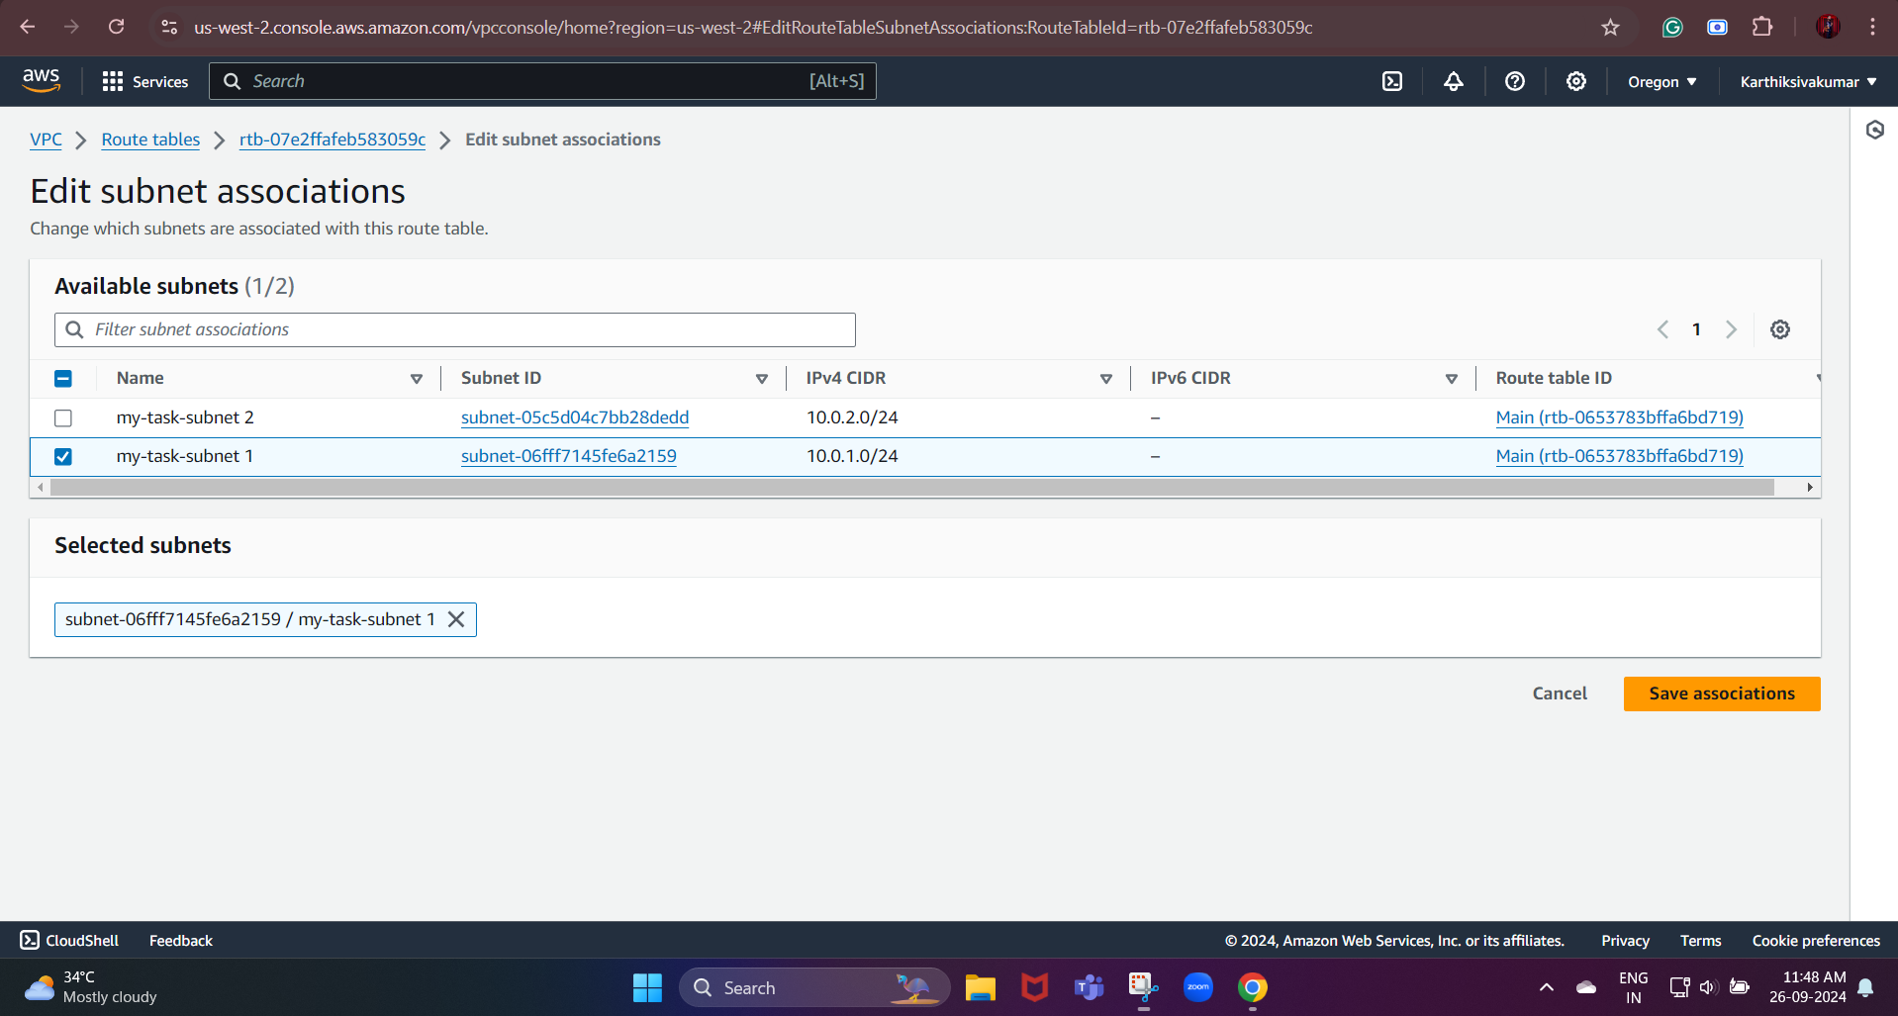

This step ensures that the public subnet uses this route table, which includes the route to the internet.

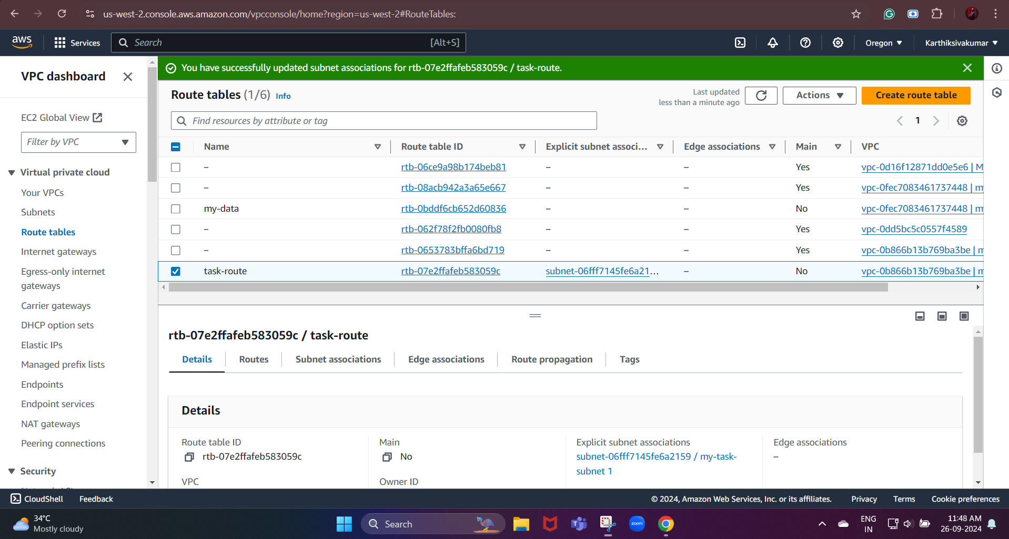

Launch a Linux EC2 instance by using the above VPC and public subnet.

First, we need to create the instance, and we need to select the minimum requirements

Network settings:

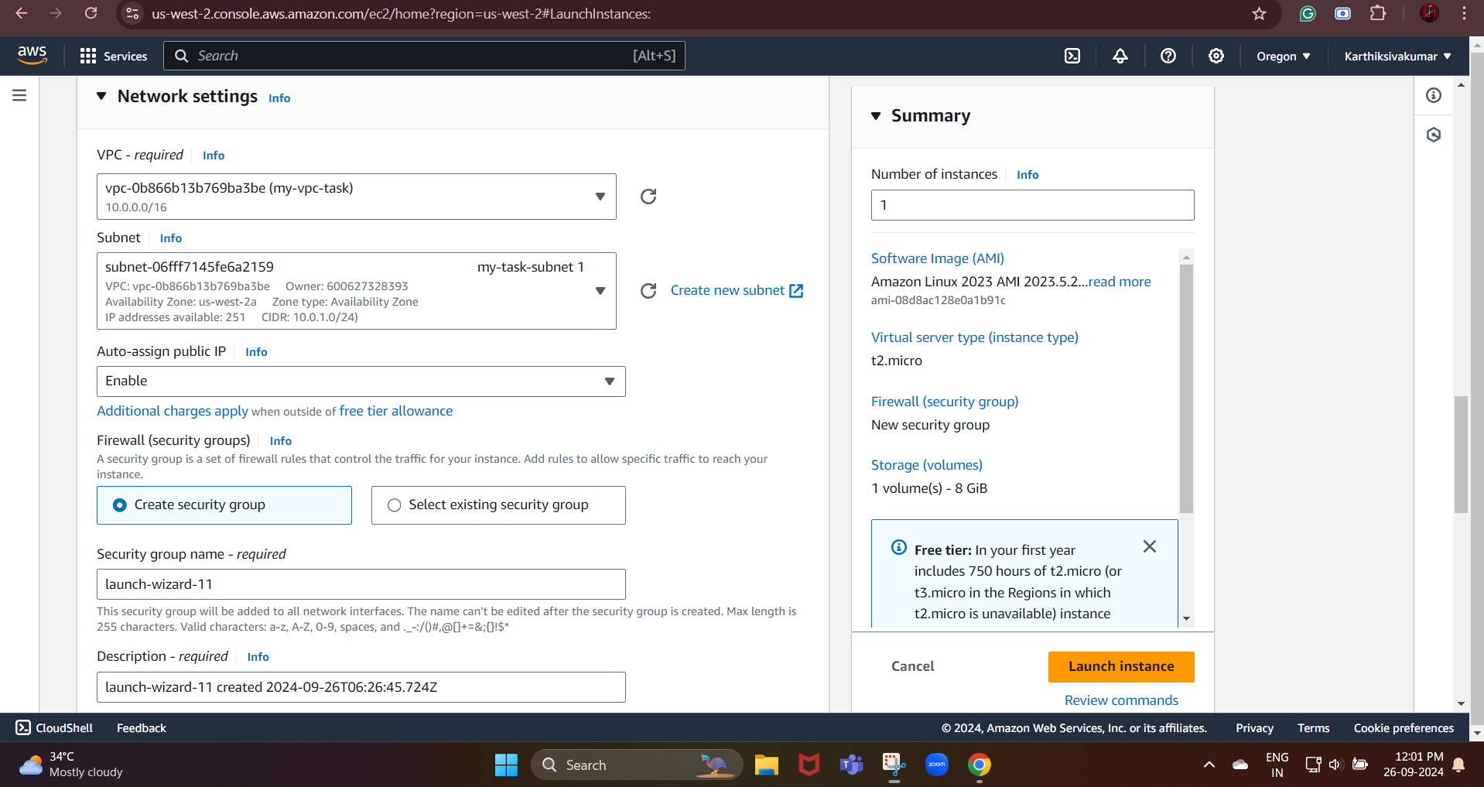

In that, we select the enable option. This will give your instance a public IP address to communicate with the internet.

* After that, we need to create the key pair and the security group for our instance.

Make sure to allow inbound SSH traffic (port 22) so you can connect to the instance.

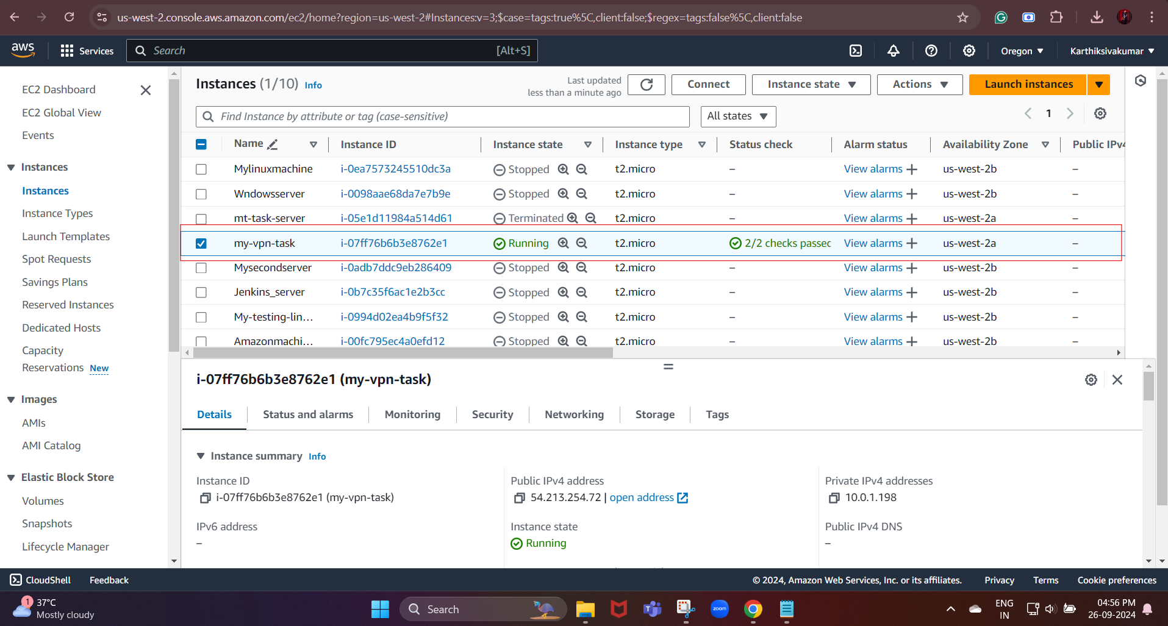

Public IP: 54.213.254.72 | (from our created instance)